Codee Online Banking Administrator Manual

Table of Contents:

1. General description……….…………………………………………………….

2. Sign in to Codee-Banking system………………………………………………

3. Manage user account……………………………………………………………

3.1 View the list of user account….…………………………………………….

3.2 Search for a special user account……………………………………………

3.3 Edit user’s profile……………………………………………………………

3.4 Delete user account………………………………………………………….

3.5 Add new user account ………………………………………………………

4. Manage transaction ……..………………………………………………………

4.1 View list of transaction…………………………………………………….

4.2 Search for a special transaction…………………………………………….

4.3 Add new transaction…..……………………………………………………

5. Manage admin’s profile………...……………………………………………….

# **1. General description**

This document describes how to manage Codee-Banking system. The Codee Banking manager can perform the following functions : sign in to Codee-Banking system, manage user, transaction, add new user, transaction for user and manage admin’s profile. In order for the administrator to manage the system well, this document describes step by step to perform the functions.

# **2.** **Sign in to Codee-Banking system**

In order to access Codee Bank you will be required to

1. Enter your username

2. Enter your password

Admin account is provided without registration. You may either be redirected to the home page if your username and password that you entered is correct or receive an error message: " incorrect username/ password" if the information you entered is incorrect. Once you sign in Codee Bank Web you will see the screen below:

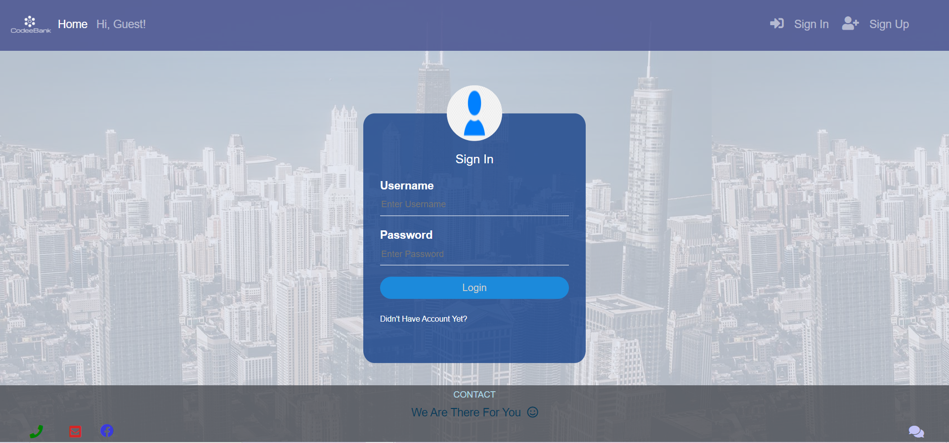

After entering the correct username and password and clicking the login button, the system will check the information and then redirect to the home page.



# **3. Manage user account: check list user account, edit user’s profile, delete account, add account**

3.1 Check the list of user accounts

First, the admin needs to check the list of users who have registered with Codee Bank. You need to click “report” section on the navigation bar and then select ”user report” option.

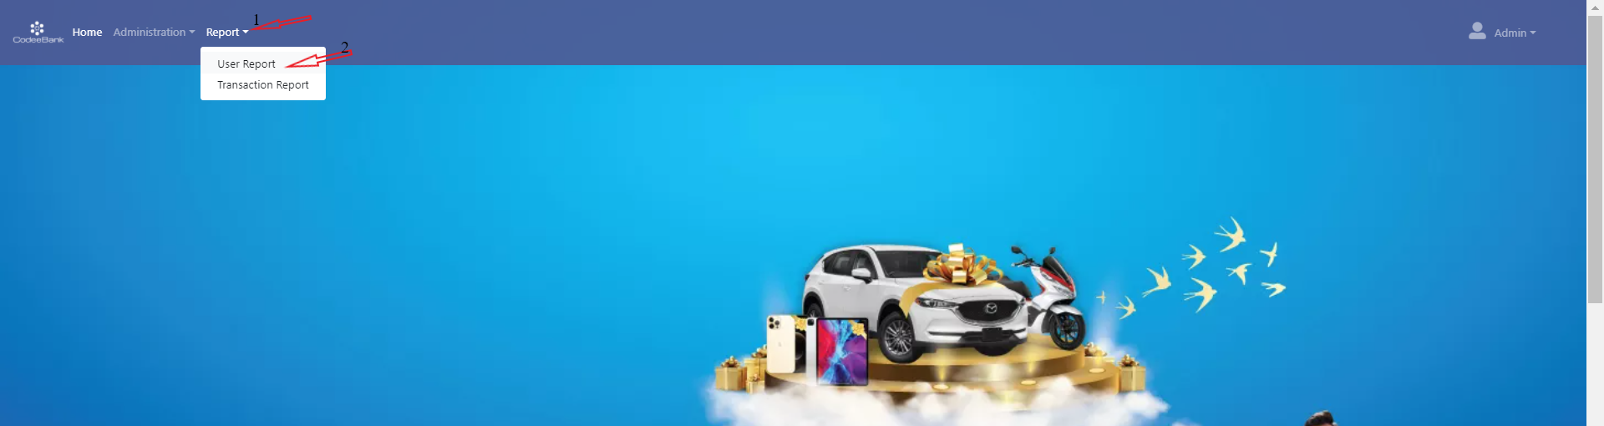

And the list of users will display with information such as account numbers, username, password…in form of a table as follows:

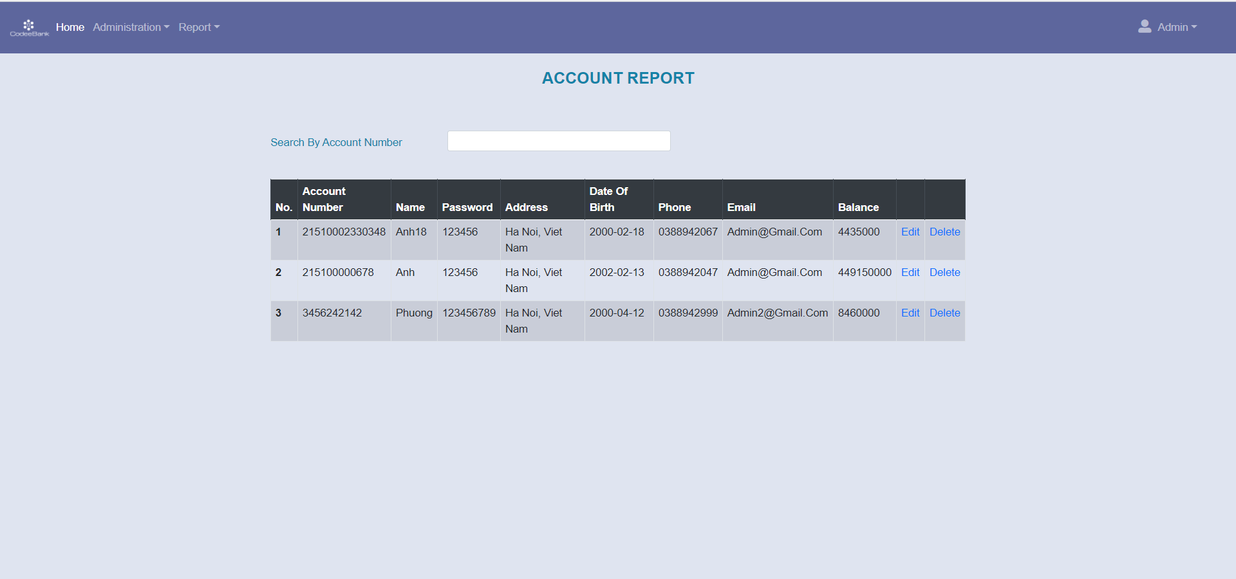

3.2 Search for a special account

To search for a special account, admin entering account number of this user in the “ Search by account number” box and the system will check and display more detailed information about this account if the account number is registerd with the Codee Bank.

3.3 Edit user’s profile

The admin has the right to modify a user's profile if a request is received from that user. To modify a user's information, admin clicks on the “Edit” button corresponding to that user's information line.

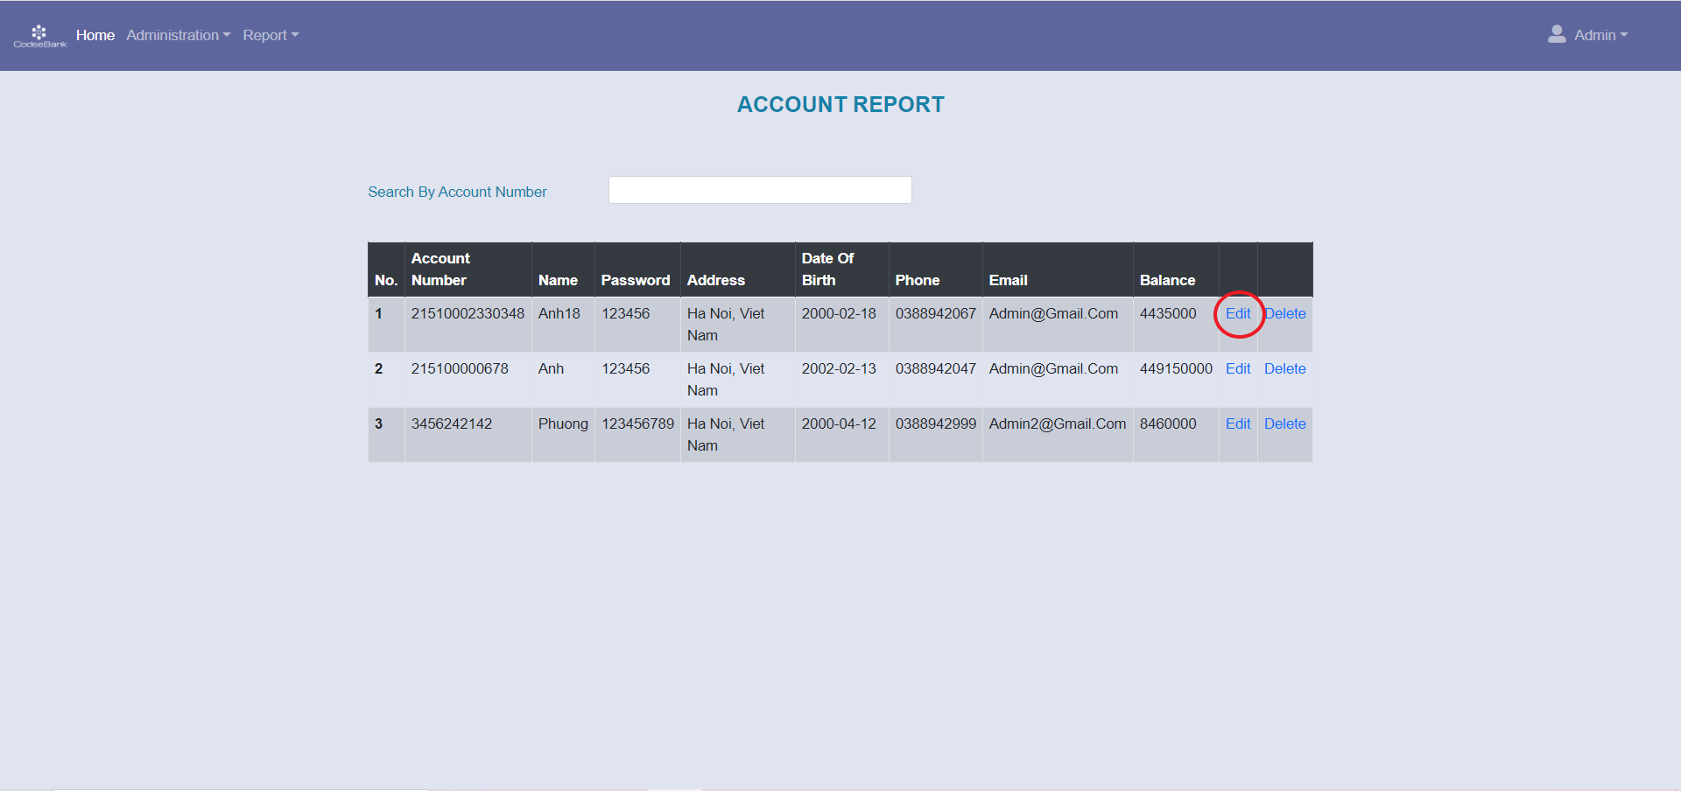

Then the user's profile will display as follows:

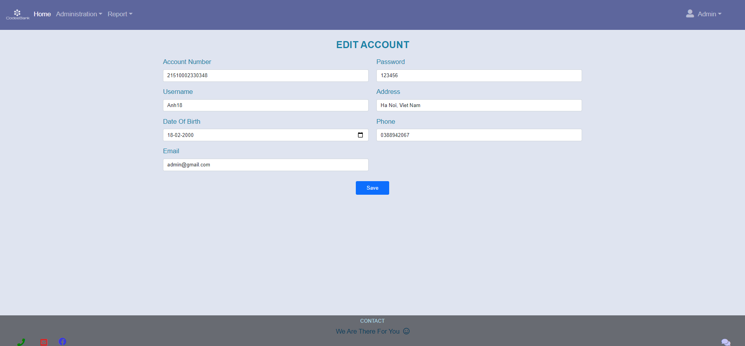

And the administrator can modify the information according to the user's request such as changing username, phone number or password…Click “Save” to save the changes to the database.

3.4 Delete account

The administrator can also delete a use’s account if requested by the user or for special reasons. Click “Delete” at the end of the information line of the user whom you want to delete. And the Codee Bank system will ask:” Are you sure to delete this account”, you can click “Ok” to delete account or otherwise, click “Cancel”.

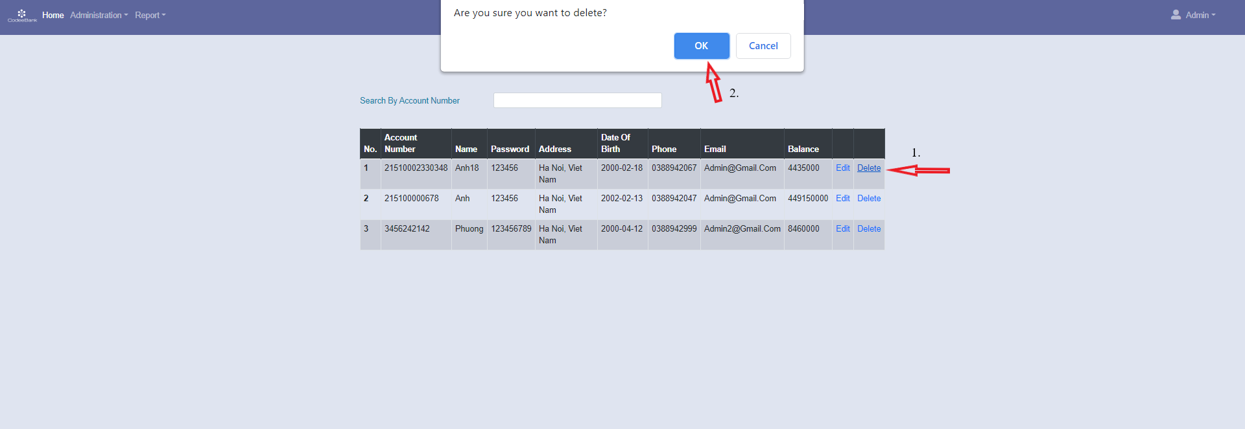

3.5 Add new user account

User can go to the Codee Bank and request creating an online Codee Bank account. The administrator will proceed to create an user account by the following step:

1. Cick administration on the navigation bar of the home page

2. Click “Add User” option

3. Fill in the customer information provided in the form, create a username and password for that account.

4. Click “Add” button to finish adding new user account or otherwise click “Cancel” button

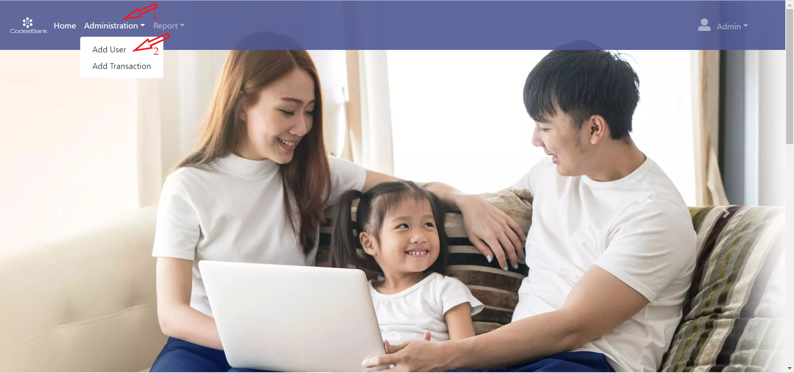

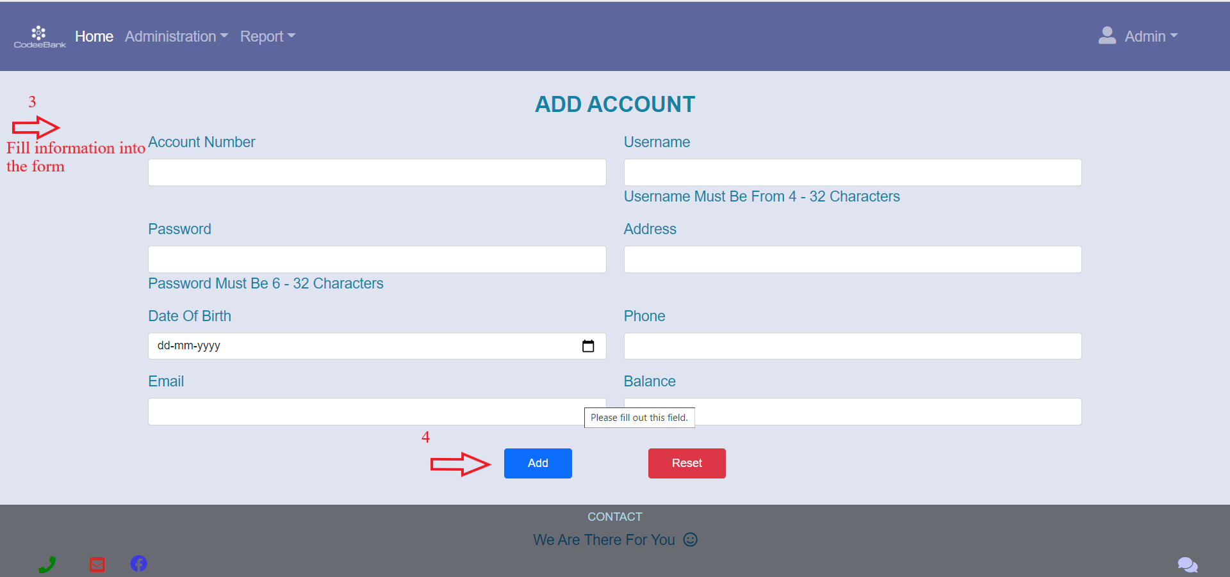

# **4. Manage Transaction**

4.1 View transaction report:

To check money transfer transactions of users, admin need to:

1. Click “Report’ section in the navigation bar of the home page

2. Select “Transaction Report” option

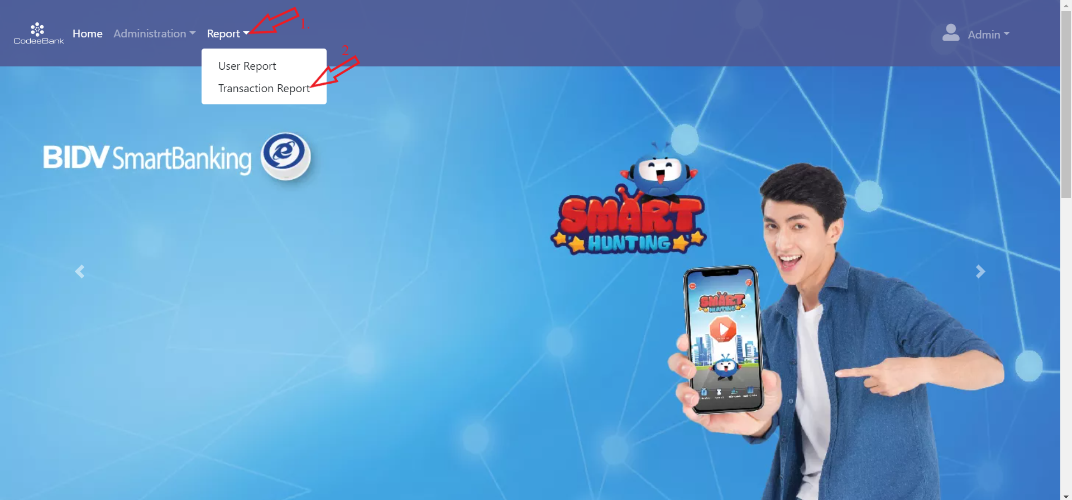

Then a table of transactions is displayed for the administrator, including information about from account number, beneficial account number, transaction amount, date& time of the transaction.

4.2 Search for a speacial transaction

In case the administrator wants to search for certain transactions that have been performed on the Codee Bank system. The administrator just enter account number in the box "search by account number" and then information about the transaction related to that account will be automaticallly displayed like this:

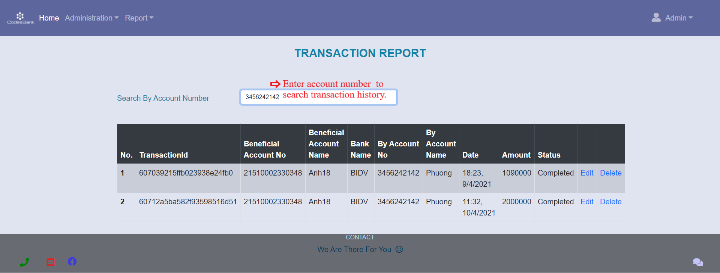

4.3 Add new fund transfer for user

The admin can also create a money transfer transaction that helps a user in case the user arrives at a bank's workplace and requests a money transfer, provides the employee with cash, and the recipient's information. The adminstrator will create a money transfer transaction for the user by using Codee online baking with the following:

1. Click “Administration” on the navigation bar of the homepage

2. Select “Add Transaction” option

3. Fill in the user information provided in the form

4. Click “Add” button to finish adding new transaction for the user or otherwise click “Reset” button.



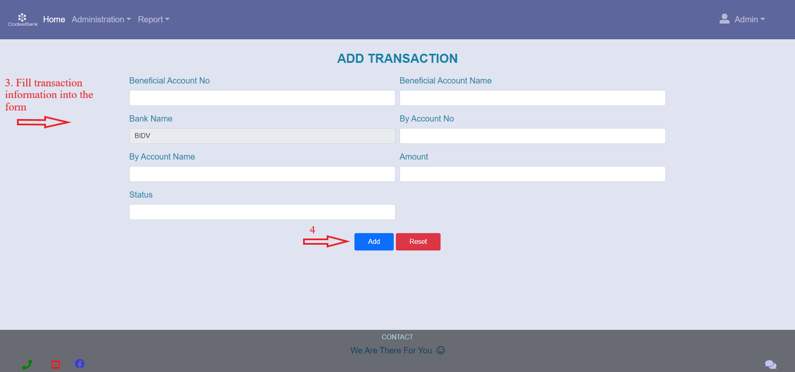

5. Manage admin’s profile

To view admin’s profile, click “Admin” in the right sight of the navigation bar, then click on “My Profile” option. Your profile will be displayed, and you can edit the information in your profile.

To edit the user name, phone number, email address, you need to delete the old information and enter new information, then enter the password in the confirm password box to verify, then press the Save changes button to save the changes.

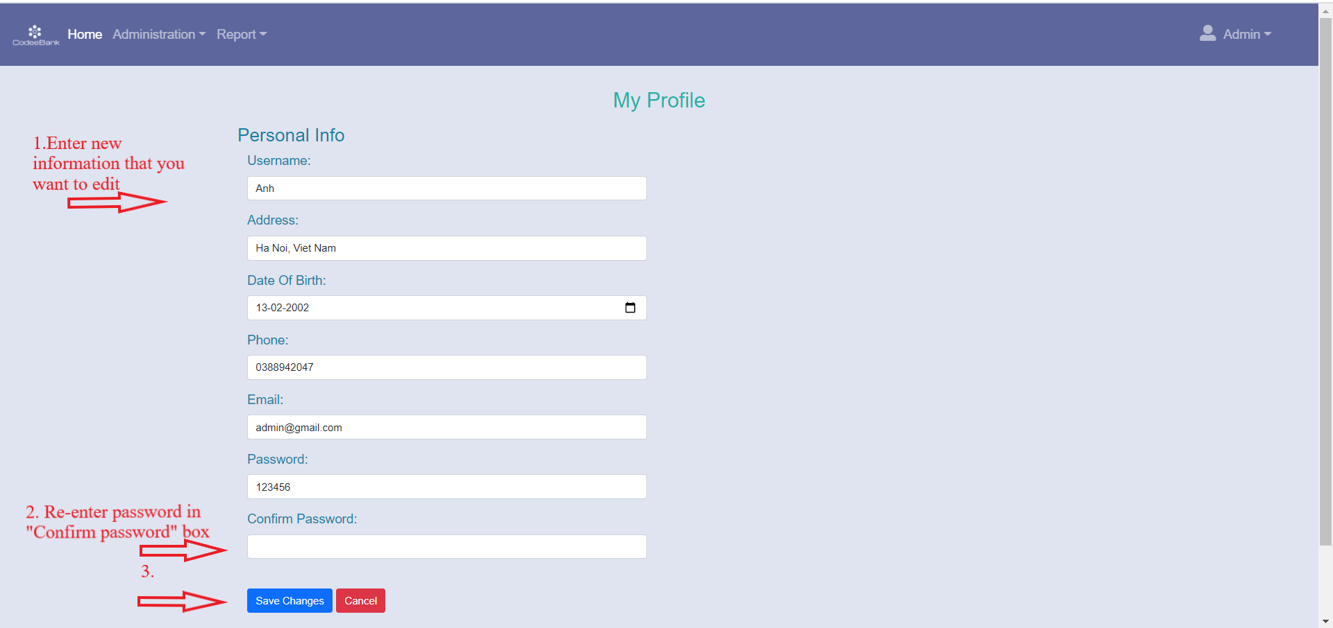

Please wait a few seconds for the system to save these changes, then re-open My profile to see the updated information. If you do not want to change personal information, please click Cancel button.

To change the password, you need to:

1. Enter the new password in the password box

2. Re-enter that new password in the Confirm password box.

3. Click Save changes button

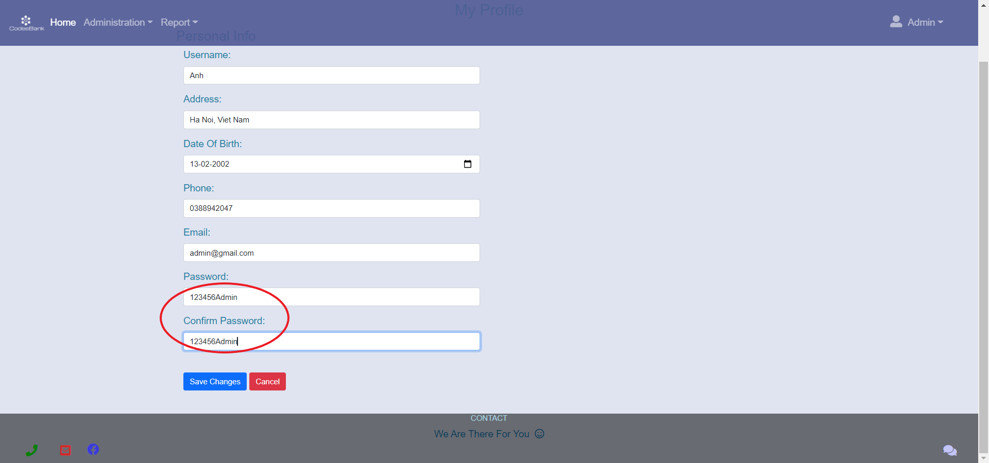

Please make sure the string you entered both times is the same. In case you entered two different character strings, the system will notify you of an error and will not make your request to change your password.

If you have any questions or mistakes, please contact the project's support team via email: sqasupport@gmail.com